**DAILY ONLINE ACTIVITIES SUMMARY**

|  |  |  |  |  |  |  |  |  |
| --- | --- | --- | --- | --- | --- | --- | --- | --- |
| **Date:** | 16/06/2020 | | | | | **Name:** | CHANDANA S | |
| **Sem & Sec** | 4th SEM ‘A’ SEC | | | | | **USN:** | 4AL18CS016 | |
| **Online Test Summary** | | | | | | | | |
| **Subject** | | Complex Analysis, Probability and Statistical Methods(18MAT41) | | | | | | |
| **Max. Marks** | | 30 | | **Score** | | | 24 | |
| **Certification Course Summary** | | | | | | | | |
| **Course** | Python Programming | | | | | | | |
| **Certificate Provider** | | | Great Learning | | **Duration** | | | 3 Hours |
| **Coding Challenges** | | | | | | | | |
| **Problem Statement:** 1. Write a C Program to perform the following operations on Triply Linked List (TLL). | | | | | | | | |
| **Status:** Completed | | | | | | | | |
| **Uploaded the report in Github** | | | | | YES | | | |
| **If yes Repository name** | | | | | https://github.com/chandushivalingareddy/lockdown-coding | | | |
| **Uploaded the report in slack** | | | | | YES | | | |

**Online Test Details:**

The online test was from module 1 which was about the calculus of complex function and construction of analytic function. There were 15 questions and the duration was 40 minutes. The questions were optimal and were easy. The score that I got in the test is 24/30.

**Snapshot:**

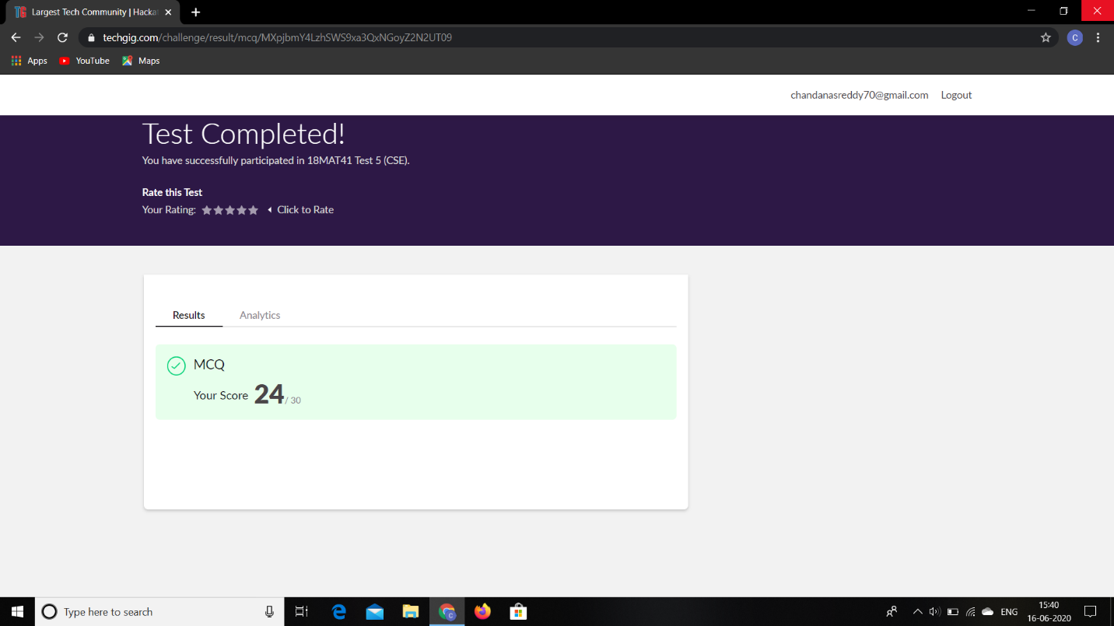

**Certification Course Details:**

**Name of the course**: Python Programming

**Certificate Provider**: Great Learning

Today I went through the data types in python.

**Snapshot:**

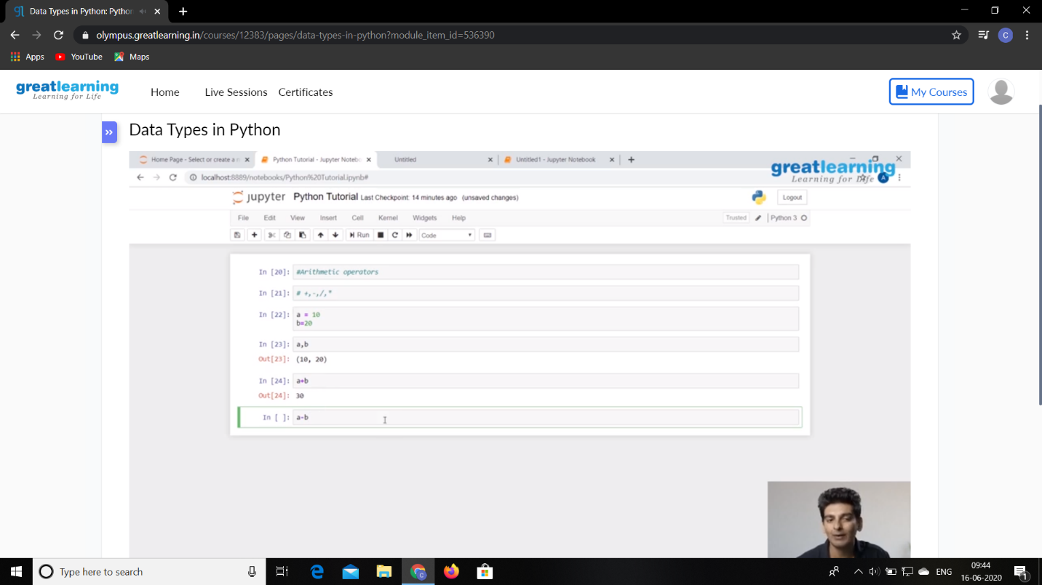

**Online Coding Details:**

Problem 1: Write a C Program to perform the following operations on Triply Linked List (TLL).

**Snapshot:**

